Standard Operational Procedure (SOP)

**Home Page:**

This homepage includes navigation buttons that provide convenient access to both I&D and FS Dashboards.  
To reach these sections, just click on the corresponding buttons.  
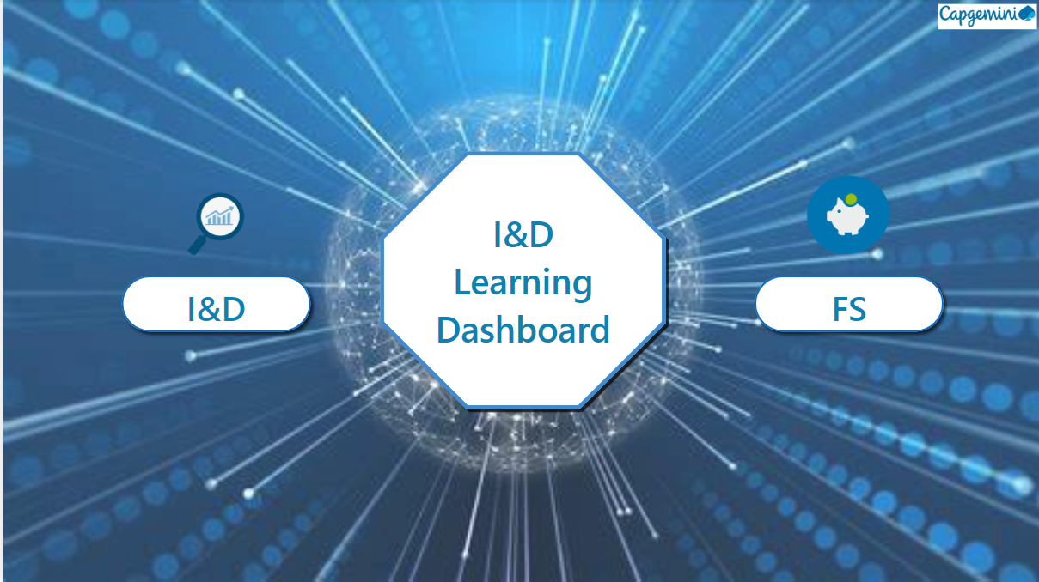

**I&D Dashboard:**This page presents visual representations of data, granting access to comprehensive insights specifically pertaining to the I&D SBU.

Within the dashboard, we've integrated two buttons, "Home" and "Clear All Filters," to improve user interaction and functionality.

To access these buttons, simply click on the respective options.

Additionally, slicers for Portfolio, Year, Country, Grade and Status are available to easily apply filters tailored to our specific requirements.

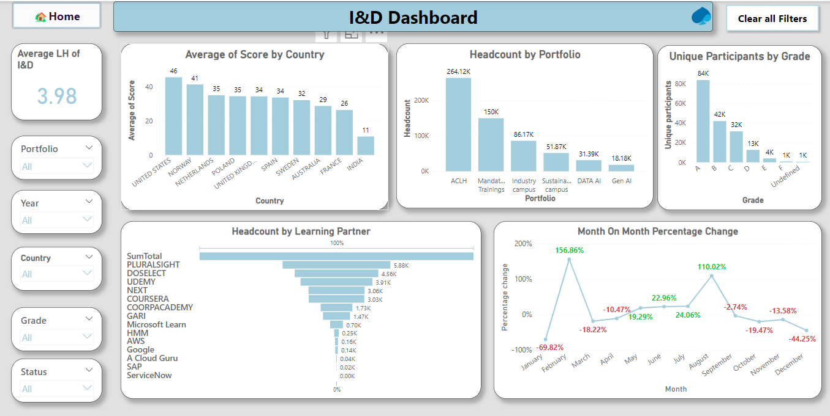

**FS Dashboard:**

This page presents visual representations of data, granting access to comprehensive insights specifically pertaining to the FS SBU.

Within the dashboard, we've integrated two buttons, "Home" and "Clear All Filters," to improve user interaction and functionality.

To access these buttons, simply click on the respective options.

Additionally, slicers for Portfolio, Year, Country, Grade and Status are available to easily apply filters tailored to our specific requirements.  
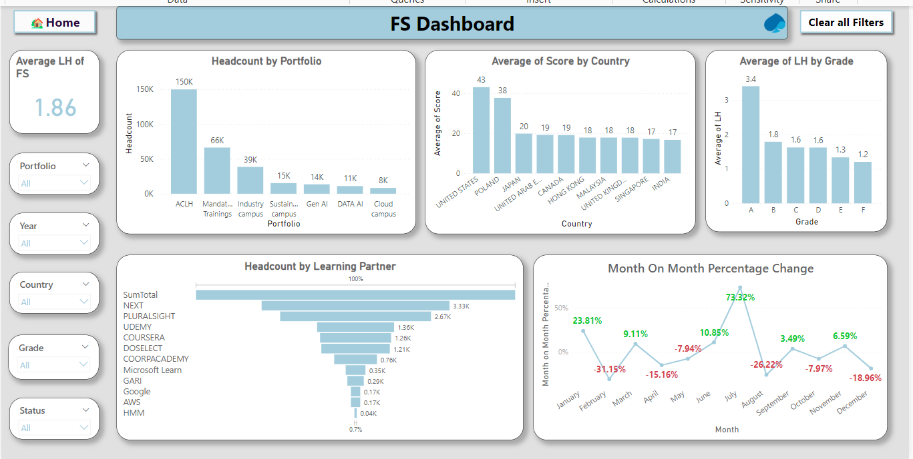

**Drill Through:**

We have incorporated drill-through functionality into the I&D and FS Dashboards to offer more detailed insights for the information presented on the dashboard.

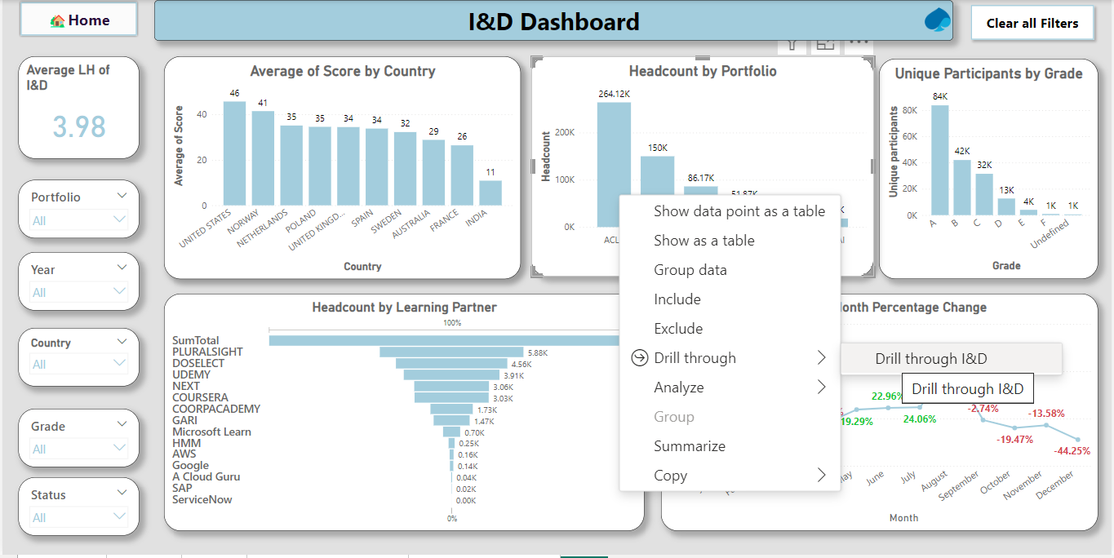

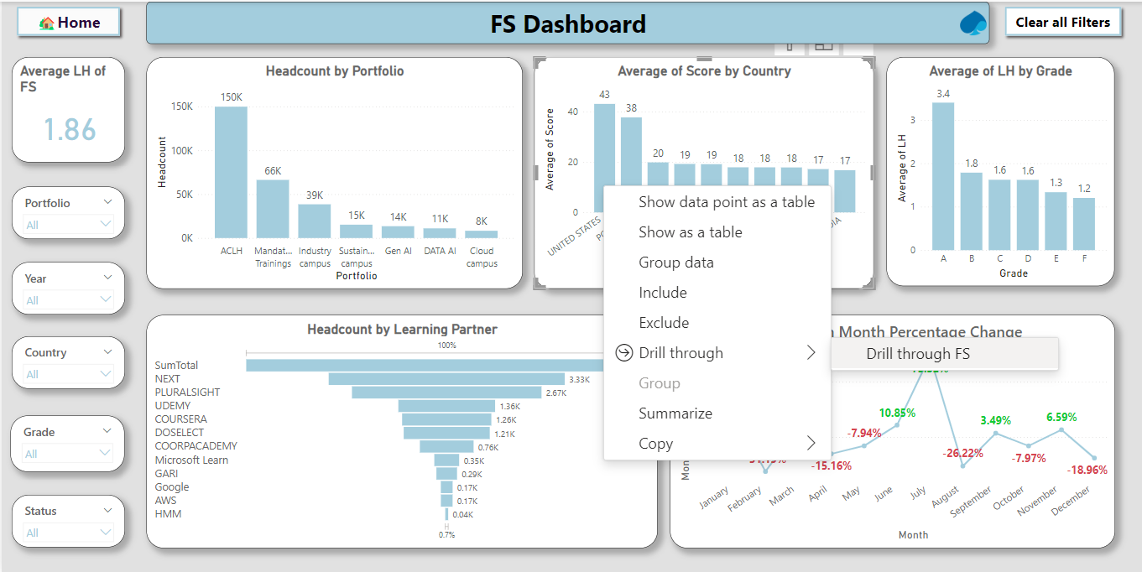

Accessing the drill-through functionality involves a right-click on specific details, allowing navigation to the corresponding Drill Through page.

**Employee Details:**This page provides concise information about each individual, featuring a search option for Titles, Email, and Employee ID Of Both FS and I&D SBU’s.

The implementation process for buttons and slicers on this page should follow the same procedure.

